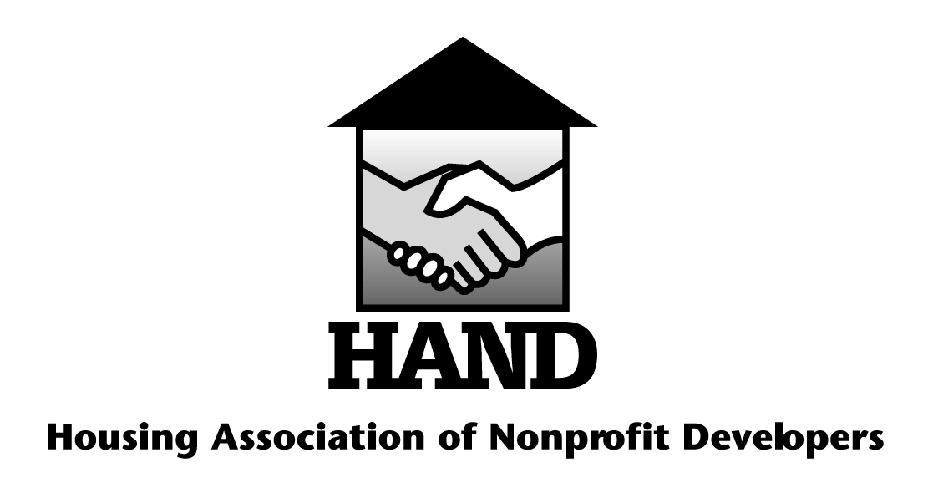

HAND’s 11th Annual Children’s Art Contest

“Who Needs Housing?”

ENTRY GUIDELINES
- The contest is open to children who attend elementary school (ages 5-12) and who reside in properties owned or operated by HAND members.
- Community Program staff should mail the top five (5) entries from each property to: Heather Raspberry, Executive Director, HAND, PO Box 48386, Washington, DC 20002. Please make sure a staff member’s contact information is on the form (below).
- Deadline for entry is April 17, 2015 at 5:00 PM. Please note, PO Boxes do not accept FedEx or UPS deliveries, so plan your deliveries via United States Postal Services accordingly. Late entries will not be accepted.
- Artwork should reflect this year’s theme, “Who Needs Housing?” We look forward to seeing your artwork that shares who you feel needs housing in your community and what it would mean to you. Is it a friend, a family member or even someone you see in your neighborhood who has made an impact on you? And what would they be able to do in a home, that they cannot do now? We look forward to seeing Who Needs Housing in your world!
- All artwork must be original work. Dimensions of artwork should not exceed 11” x 17” in size and be 2-dimensional. Acceptable media are paint, pencil, markers, ink, crayon, chalk or pastel. Please tape a completed entry form to the back of each piece of completed artwork.
- Artwork must be done on paper that will allow for duplication and display. Do not mat, mount, laminate, frame or fold artwork. Entries must be mailed flat or rolled in a tube - no folding, please.
- Submissions become property of HAND. Through submission of artwork, contestants and their legal guardians grant non-exclusive reproduction and publication rights to the works submitted.
- Grand Prize: a $250 cash prize awarded to winner; The winner’s Community Program or Center will also receive a cash prize of $250 for administering the contest. Grand prize winner must be available to attend the HAND Annual Meeting on June 23, 2015 to receive their prize. Eight runners-up will each receive $25 gift certificate.
- If you have questions regarding the contest, please contact Heather Raspberry, HAND Executive Director, at hraspberry@HANDHousing.org or 202.754.1311.

HAND’s 11th Annual Children’s Art Contest

“Who Needs Housing?“
Attach completed form to the back of the artwork submission.

Student’s Name:

Date of Birth: Grade:

Address:

Parent/Guardian’s Name:

Phone Number:

Name of Property/Development:

HAND Member Organization:

HAND Member Contact Person:

Phone: E-mail:

Legal Notice:
As part of your submission of artwork associated with this contest, you acknowledge and declare that your artwork submitted to HAND (Housing Association of Nonprofit Developers) is original, and that you as the artist hold exclusive copyright of your artwork and hereby transfer exclusive copyright for this material to HAND for the use of the organization.

The following rights are waived by the undersigned:
- The right to make claim of ownership or suit against HAND, all or in part for the reproduction, use, or intent to generate revenue with the aforementioned artwork.

The following rights are retained by HAND:
- Reproduction of said image(s) in future works of their own, such as marketing or public relations materials.
- HAND also retains the rights to include the article on their Web site or in future publications.
- Electronic or print copies may be made for commercial and non-commercial use.

If you have questions or concerns regarding this form, please contact Heather Raspberry, HAND Executive Director, at hraspberry@HANDHousing.org or 202.754.1311.

Please acknowledge that you have read and understood the above notice:

______________________________________________ ________________________
Signature of parent or guardian Date

