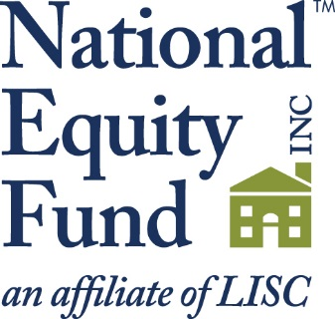

The National Equity Fund, Inc. (NEF), the largest non-profit syndicator of low-income housing tax credits, is seeking an Originations Officer for our
southeastern territory, with particular focus on Florida, Georgia, and the Carolinas. The main functions of this position are to market, structure, negotiate, and originate low-income housing tax credit investments that are consistent with NEF’s objectives. The Originations Officer is responsible for securing transactions in a manner which manages all expectations in order to maintain developer relationships while sill delivering anticipated benefits to investors. Transactions must be structured up front, such that the viability of the real estate is maintained for the term of the Partnership, thus providing quality housing in communities across the region. This individual is also responsible for cultivating and maintaining relationships with a variety of intermediaries, organizations, and agencies involved in the affordable housing industry, with particular attention to LISC non-profit organizations.

The ideal candidate will have a college degree in business, economics, urban planning, real estate, or finance. Minimum 3 years’ experience in structuring and originating real estate transaction. Prior knowledge and/or experience with the LIHTC program including affordable housing finance vehicles and state and local programs is a huge plus. Skill sets must include superior oral/written communication; understanding of industry business terms, ability to work on numerous projects at once, strong analytical abilities and proficiency in Excel. Applicant must possess competencies to market complex financing structures to non-profit and for-profit sponsors/developers. Ability and willingness to travel is required.

We offer a competitive salary, along with a comprehensive benefits package.

Submit resume and cover letter with salary requirements via fax to (312) 360-0804,
e-mail to rhall@nefinc.org, or mail to The National Equity Fund, Human Resources Department, 10 South Riverside Plaza, Ste. 1700 Floor, Chicago, IL 60606.

NEF IS AN EQUAL OPPORTUNITY EMPLOYER

