Housing & Homeless Services Emerging Leadership Institute

Virginia Housing Alliance

Description
A three-day program that will provide rising leaders in the affordable housing industry with tangible knowledge and resources in the areas of leadership, communication, diversity, management practices and self-development. In addition, participants will build a network of committed colleagues across the Commonwealth. Upon completion of the program, participants will be able to assimilate what they have learned to their work environment to enhance employee engagement and productivity, contributing to organizational success.
The three-day ELI experience will be offered in Norfolk (Spring 2019), Arlington (Spring 2019).
The dates for each session are as follows:
Norfolk: Fridays, April 5; May 10 and June 28
Arlington: Mondays, April 22; May 20 and June 24

Overview
Building on the success of the Emerging Leadership Institute (ELI) in Richmond in Spring and Fall of 2018, the 2019 program will follow a similar design. The program will consistent of three full days of training over 3 consecutive months.

Session | Topic
Day One | Leadership and Emotional Intelligence  Leading and Developing High Performance Teams
Day Two | Comprehensive Performance Management
Day Three | Managing Conflict  Fostering Shared Vision and Strategic Change  Guest Speaker  Closing Activity/Graduation

Biographical information
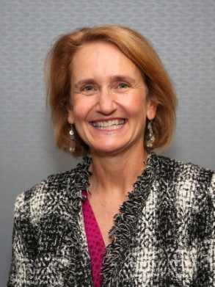
Susan Brock Wilkes, Ph.D., is an independent consultant specializing in leadership development to strengthen mission-focused organizations including nonprofits and faith-based organizations. Susan is an organizational psychologist with extensive experience in leadership and team development, executive coaching, strategic planning and facilitation. A recipient of the Instructor of the Year Award from The Community Foundation (formerly Nonprofit Learning Point), Susan is the founding faculty member for its successful Emerging Nonprofit Leaders program and has taught in the program for 11 years. Prior to founding her own firm, Susan served on the faculty of Virginia Commonwealth University for twenty years.

Examples of recent consulting engagements include facilitation of the Mayor’s Summit on Affordable Housing, Board and staff retreat for Liberation Veteran’s Services, and the strategic planning process for Sacred Heart Center. She has recently custom designed multi-session leadership development programs for the Virginia Early Childhood Foundation, the Environmental Protection Agency, Southern Environmental Law Center and UMFS.

Susan is a founding member of the ConsultCorps for the Center for Nonprofit Excellence in Charlottesville and on the faculty of the Chrysalis Institute nonprofit where she teaches mindfulness classes. She is honored to be a co-founder of “Impact100 Richmond” and to serve on the board of Health Brigade (formerly Fan Free Clinic). Her latest publication is "Strengthening the Next Generation: A Multi-faceted Program to Develop Leadership Capacity in Emerging Nonprofit Leaders" in the Journal of Nonprofit Management and Leadership.

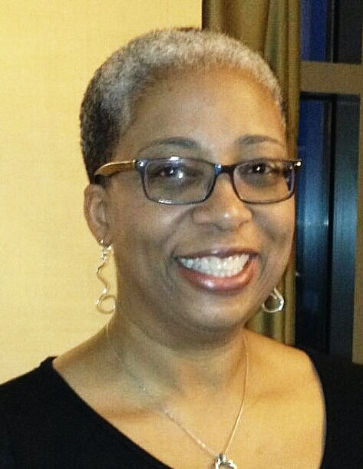
Tammy Jackson is the Senior Vice President and Chief Human Capital Officer for Virginia Community Capital. She has over 25 years consulting, coaching, training design and facilitation experience. Previously, Tammy was Senior Consultant at the Performance Management Group in VCU's L. Douglas Wilder School of Government & Public Affairs and the Organizational Culture Administrator in Human Resources at VCU.

Tammy is also an independent consultant and trainer through her company, Positive Impact Consulting. Her areas of expertise include organizational assessment and development, strategic planning, leadership and supervisory skills, diversity awareness and management, conflict resolution and collaborative efforts among public agencies. Tammy is an award-winning trainer known for her ability to create a comfortable and interactive learning environment while maintaining focus on the level of detail needed to make the training material applicable when participants return to the workplace.

Prior to her work at VCU, she was an executive level training and development professional with a Fortune 500 company. Ms. Jackson is active in the community and serves on several nonprofit Boards of Directors.

