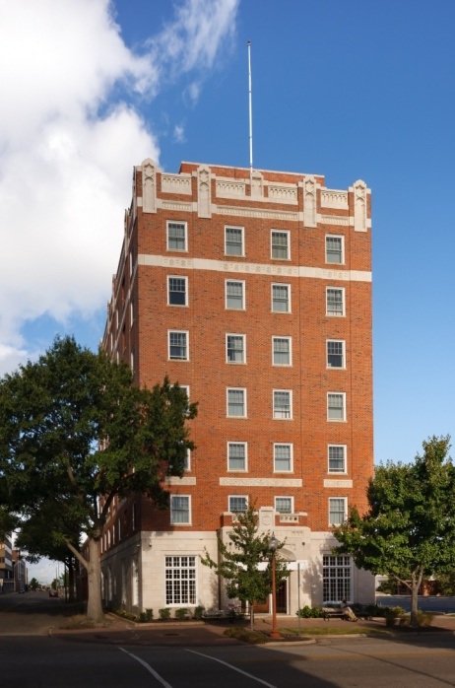
Timeline
1/2010: Exit negotiations begin with LP
1/2010-2/2011: Restructuring of existing debt (VA Housing Partnership Fund, AHP, Newport News Redevelopment and Housing Authority)
11/2010: End of Initial 15 Year Compliance Period
12/2010: LP Exits
3/2011: 9% LIHTC applications submitted to VHDA
6/2011: The Warwick awarded credits
10/2011: Equity closing; construction begins
11/2012: Construction completed; C of O
4/2013: Achieved stabilized occupancy

Critical Issues
- Exit Fees requested by LP
- Disposition of the Operating Reserve
- Attempt to negotiate portfolio-wide exit policy
- Restructuring of project soft debt
- LP expectation of resyndication
- Tax credit guarantees extension beyond LP Exit

